Justin Hartwick
CS 499
Milestone Three Narrative
Enhancement Two: Algorithms and Data Structure

Artifact Description
The artifact selected for this enhancement is a MongoDB-based dashboard application originally created during my CS 340 coursework. The project uses a MongoDB database containing animal shelter outcome data and a Python-based application layer to query and display filtered results. The artifact was originally developed to demonstrate basic CRUD functionality and database interaction. For this milestone, the artifact was enhanced to focus specifically on query execution behavior, algorithmic efficiency, and the impact of data structures such as indexes on performance.

Justification for Inclusion in ePortfolio
I selected this artifact for my ePortfolio because it provides a clear and practical demonstration of algorithmic principles applied in a real-world database context. While the application itself is relatively simple, the underlying query behavior highlights important concepts related to algorithms and data structures, including linear search, indexing, and performance trade-offs.
The enhancement focused on analyzing how MongoDB executes queries when an index is not present. Using MongoDB Compass, I executed a filtered query on the animal_type field and examined the resulting execution plan. The explain plan showed a collection scan (COLLSCAN), meaning every document in the collection was examined to locate matching results. This behavior directly reflects a linear search algorithm, where time complexity increases proportionally with dataset size.
This artifact showcases my ability to analyze algorithmic efficiency, interpret execution metrics, and evaluate how data structures such as indexes can significantly improve performance. By identifying the absence of an index and observing its effect on query execution, the artifact was improved from a basic database interaction into a meaningful demonstration of algorithm and data structure concepts.

Course Outcomes and Planned Coverage
This enhancement meets the course outcomes I identified in Module One, particularly the outcome related to designing and evaluating computing solutions using algorithmic principles. Through this milestone, I demonstrated an understanding of how algorithmic choices and data structures impact performance and scalability.
No changes are needed to my original outcome-coverage plan. However, this enhancement strengthened my ability to explain these concepts clearly and apply them within a database environment, which further supports my progress toward program-level competency.

Reflection on the Enhancement Process
Enhancing this artifact helped reinforce the connection between theoretical algorithm concepts and practical implementation. While databases often abstract algorithmic behavior, reviewing the explain plan made it clear that fundamental principles such as linear search and indexing still apply. Seeing how a query examined all 10,000 documents to return a subset of results provided a concrete example of why algorithmic efficiency matters.
One challenge during this process was configuring the local MongoDB environment correctly, particularly managing authentication and service settings. Troubleshooting these issues required careful attention to system configuration and reinforced the importance of understanding the tools and environments used in computing solutions.
Overall, this enhancement deepened my understanding of how algorithms and data structures operate behind the scenes in modern applications. It also improved my ability to analyze performance, communicate technical findings, and make informed design decisions that support scalability and efficiency.

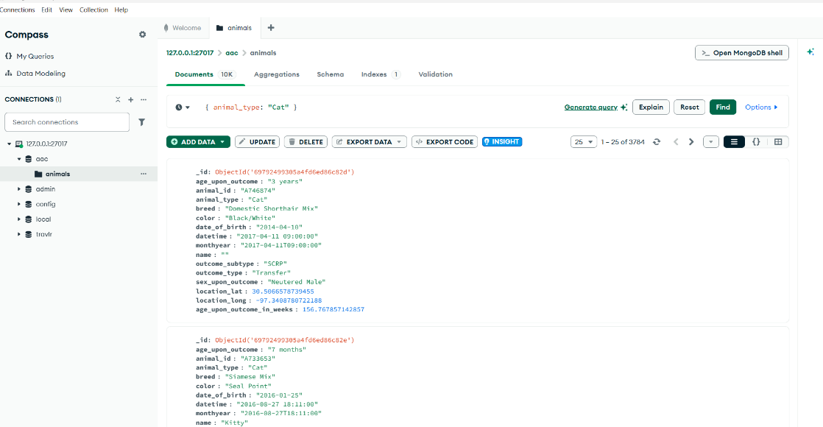
Figure 1 Filtered query executed without an index, resulting in a collection scan.

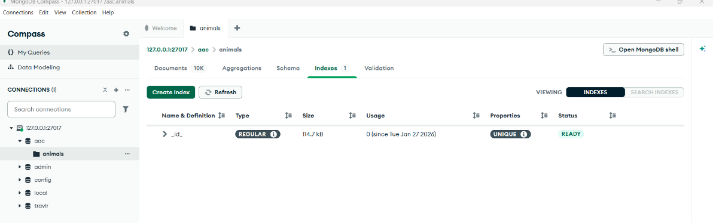
Figure 2 Index view showing no index on the animal_type field.

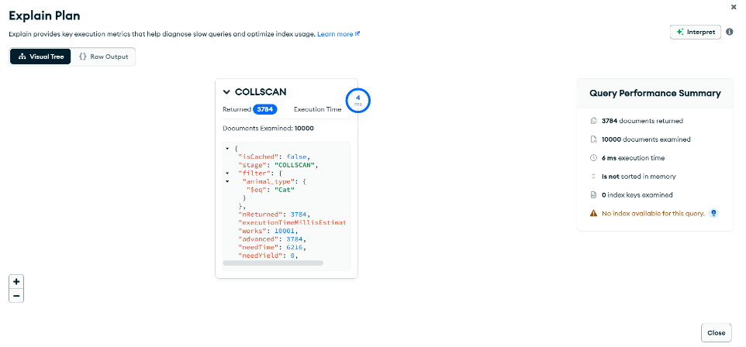
Figure 3 Explain plan output demonstrating a linear scan across the collection.

